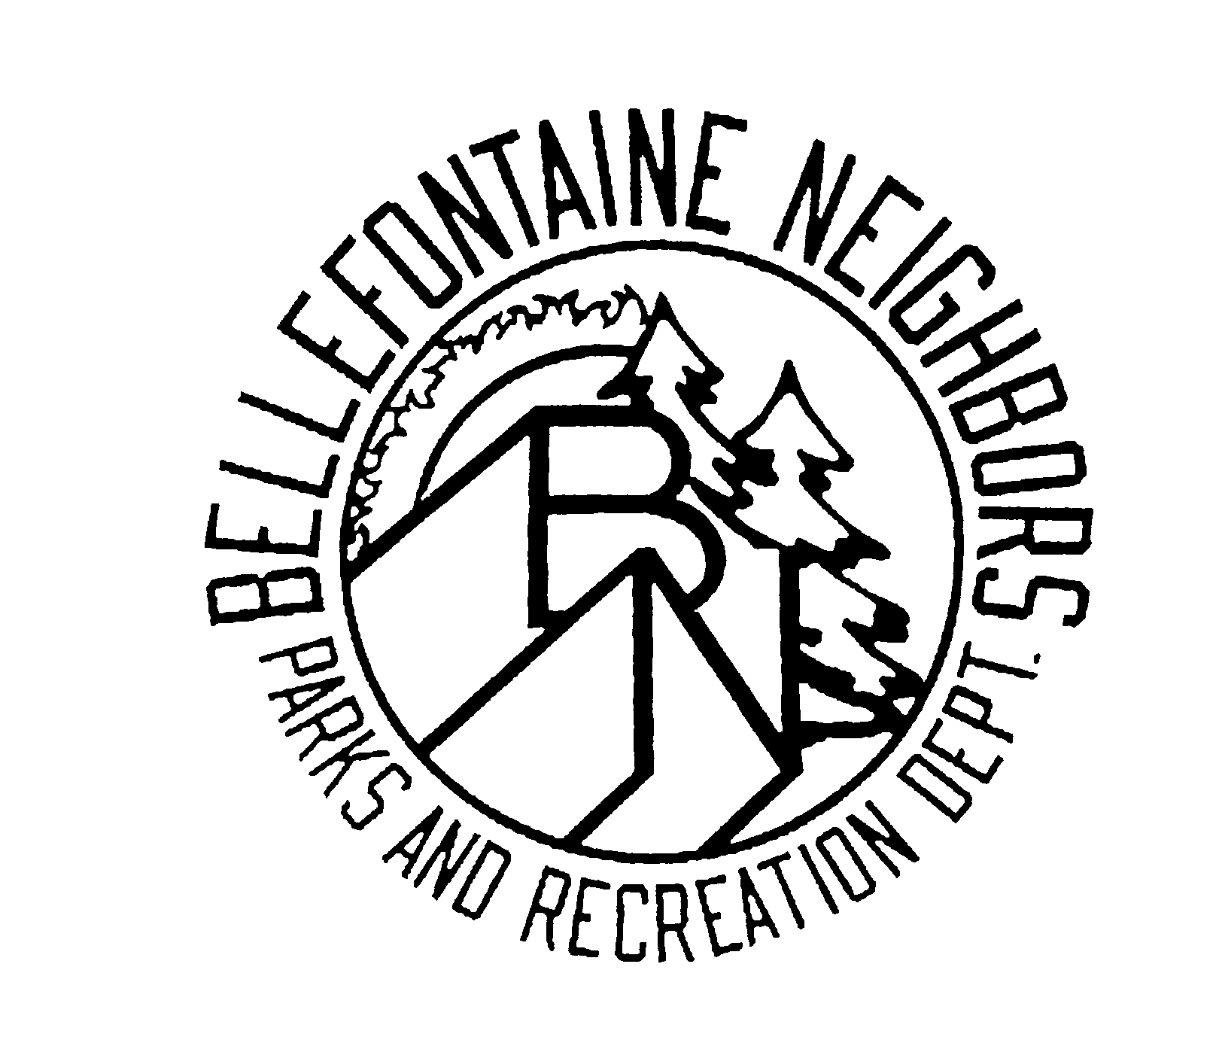
Bellefontaine Neighbors
Parks & Recreation Department
9669 Bellefontaine Road
Bellefontaine Neighbors, Missouri 63137
(314) 867-0700

APPLICATION FOR USE OF CITY PARK PICNIC AREA - Please Print
All reservations are first come, first served but please call the Bellefontaine Recreation Center to check a date. Residents may reserve any of the 3 shelters. Nonresidents may reserve Tanglewood only. Payment must be made in person before your reservation can be placed on the calendar.

St. Cyr Shelter___________ Bissell Hills Shelter__________

Tanglewood Shelter_________

Today's Date______________________

Applicant_____________________________________________________________________________________

Address________________________________________________Phone_________________________________

Name of Group__________________________________________ Number in Group_______________________

Reservation Day & Date_____________________________________________ Hours _________________to dark

Beer is the only alcoholic beverage permitted on park grounds. Will your group be consuming beer? Yes No
Will you be renting a play structure or petting zoo animals of any kind? Yes No
Please note: If you are renting a commercial structure or service that will be brought onto park property the company or supplier must submit a copy of insurance naming the City of Bellefontaine Neighbors as an additional insurer for $1,000,000.00 per incident. This must be received by the Recreation Center staff prior to your reservation date. Private play structures or pools are not permitted.
All permit holders are responsible to help keep the park clean and prevent damage to city property.

HOLD HARMLESS AGREEMENT

This agreement entered into on the _______ day of _______________, 20___, by ____________________________ of the county of St. Louis, the city of _____________________ and the state of Missouri, agrees to hold the City of Bellefontaine Neighbors, its agents, servants and employees harmless from any and all liability, actions, causes of actions, claims, demands for suits whatsoever resulting from or arising out of personal injuries, loss of or damage to property, or involving any impairment of or damage to any right because of or in any way relating to the City resulting from the use of any City park property for _________________________________________.

Signature____________________________________________________________________
---------------------------------------------------------------------------------------------------------------- ----------------------------

PERMIT
This permit is valid on reserved date only, is subject to revocation at any time and is subject to all ordinances and regulations governing the use of parks in the City of Bellefontaine Neighbors. Failure to leave the park in a clean and orderly fashion will result in forfeiture of future park reservations.

Possession of picnic area must take place one (1) hour after time given or permit is forfeited.

________________________________________________Date: ____________________________

Fee________________________ Date________________________ Staff initials______________________

