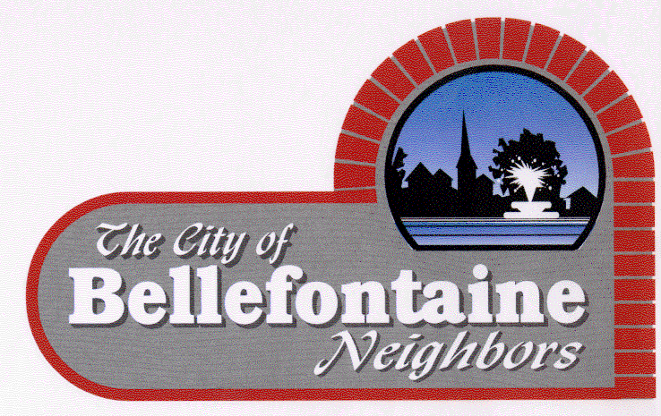
Parks and Recreation Department
9669 Bellefontaine Road
St. Louis County, Missouri 63137
(314) 867-0700 Fax (314) 867-9517

Parks & Recreation Board
Meeting Agenda

Tuesday April 19, 2022
6:00 p.m.
Call to Order
Roll Call
Approval of the Agenda
Approval of the Minutes from the Previous Meeting dated March 15, 2022

Citizen Comments

Report of the Parks & Recreation Director, Jimmy Kirincich

Old Business
- Brochure Format
- Membership Fee Structure

New Business
- Easter Egg Hunt – evaluation of location
- Summer Programs – Youth Pool Party
- Future Programming ideas

Adjourn

